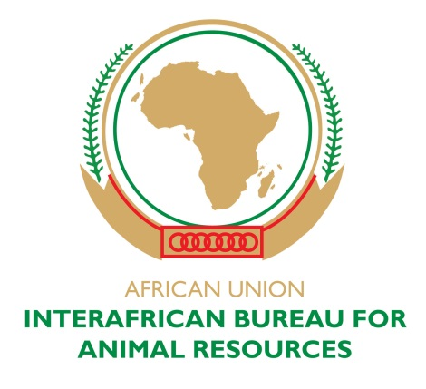

MINUTES

ONLINE MEETING OF THE NEW EXECUTIVE COMMITTEE OF THE AFRICAN ASSOCIATION OF VETERINARY EDUCATION ESTABLISHMENTS (2A2E-V)

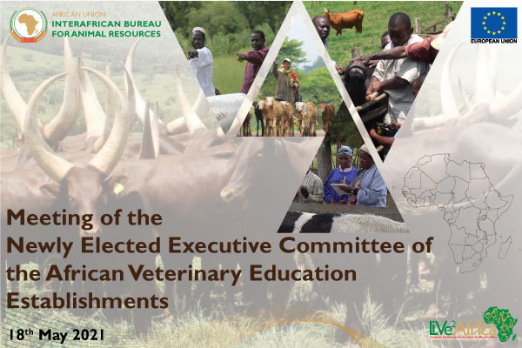

AU-IBAR, Tuesday 18TH MAY 2021

Agenda

- Introduction of the newly elected Executive Committee of the Veterinary Education Establishments

- Discussion on mandate of the new EC

- Strategic Objectives of the new EC

- Conclusion and Way forward

- AOB

The meeting was officially opened by Prof. James Wabacha of AU-IBAR who then handed over the floor to the new President of the Executive Committee – Prof. Dietmar Holm.

Prof. Dietmar welcomed all members of the Executive Committee and thanked them for taking the time to attend this important meeting. Congratulatory messages were extended to the newly elected members of the EC following the conclusion of the 2nd General Assembly of 2A2E-V which was held on 29th May 2021.

Apologies were extended for the lack of interpretation for our francophone members and it was agreed that interpretation be present for the next meeting.

Introductions were done for the new EC members: -

- Prof. Dietmar Holm, University of Pretoria in South Africa - President
- Prof. Noursaid Tligui, IAV Hassan II, Tunisia – 1st Vice President
- Prof. Adem Hiko Woshie, Haramaya University, Ethiopia – 2nd Vice President
- Prof. Adebayo Akinloye, Federal University of Agriculture, Abeokuta – Secretary
- Prof. Pati Pyana, Université Pédagogique Nationale, DRC – Treasurer
- Prof King Nalubamba, University of Zambia, Zambia - Member
- Prof. Youssef Sidime, ISSMV Dalaba, Guinea - Member
- Prof. Arouna Njayou Ngapagna, Université des montagnes, Cameroun - Member
- Prof. Adil Salman, University of Bahri, Sudan – Member
- Prof Mohamed Ghanem, Benha University, Egypt – Member

Prof Holm informed the EC that he had shared a google information sheet for the members to share their information. The main aim of this is: -
- To have details of all members of the EC in order to facilitate communication and team work
- To share congratulatory letters to respective institutions, that you have been elected to the committee and what your position is. This is good to put the 2A2E-V on the map

Prof. Holm was pleased with the addition of Madam Patricia Lumba to the group, due to her Knowledge Management skills and also in terms of all the information systems requirements of 2A2E-V. A lot of the work that the committee wants to do is limited by the capacity to manage information, so Patricia will make a big difference for the EC.

Discussion Points

Physical Meeting
- Prof. Holm requested feedback from the members of the EC on the possibility of a physical face to face meeting based on the challenges that we have experienced with the COVID-19 pandemic. The options would either be South Africa where Prof. Holm would have been pleased to host and also arrange a visit to the University of Pretoria (Faculty of Veterinary Science) or to Nairobi, Kenya which provides easy air travel around Africa

- It would be important to take certain things into consideration most importantly COVID-19 Restrictions, VISA facilitation and ease of entry into the suggested countries.

- Most members of the EC agreed South Africa would be a good option but there may be challenges in terms of entry VISA which has been experienced before. The decision was made that if it was not possible to hold the meeting in SA then Kenya is the next best option. The suggested dates for the meeting would be in last week of July 2021 but this will be discussed more at the next meeting of the EC

Google Information Sheet
- Prof. Holm shared earlier a google information sheet for each member of the EC to share their information for future records. It seems some were not able to access the sheet and requested Madam Patricia to assist.

Flyer for the EC Members
- A flyer of the new EC members had been developed by Jemima. Madam Patricia will fine tune this flyer with the shared details of the committee members and share it on the AU-IBAR website. It will also be sent to the VEEs with the communique of the 2nd General Assembly meeting which was held on 29th May 2021.

Mandate of the EC
- Prof. Holm mentioned that possibly from the meeting which will be held either in Pretoria or Nairobi then the work for the EC will begin.

- There are two representatives for every region of Africa, each of the members is an office bearer being President, 1st Vice President, 2nd Vice President, Secretary, Treasurer or Member. The Idea would be that each other member (not office bearer) of the EC acts as a liaison with the VEEs for their region so as to create a well-coordinated network within Africa. This idea was received well. Prof. Bayo mentioned that information gathered during their tenure would be of good use to the next EC.

- Prof Holm explained further that an Agenda be set up accordingly for every online meeting and allow all members to give high level feedback about current situations in their regions.

- It is important to create communication links so as to better understand what is happening in the continent. Members of the EC would collect feedback from their regions and share in future EC meeting. This idea was seconded by Prof. Sidime and Prof. Tligui

- Members of the EC would collect Information on what is happening in various institutions in the Veterinary Departments, new developments, curriculums, resources, activities etc. This information is very critical for future developments of the VEEs. Prof. King, Prof. Hiko and Prof. Ghanem seconded this proposition.

Strategic Objectives of the EC

- Prof. Holm then shared a document from the previous EC. At that stage it was just a plan as part of a Strategic Plan which pointed out six (6) major objectives: -

- Enhance Collaboration among VEEs
- Establish Continental Quality Assurance
- Harmonize Veterinary Curriculum
- To enhance dissemination of Innovation and good practice amongst VEEs
- To build capacity amongst educators in Africa VEEs
- Promote quality facilities at African VEEs

- Prof. Holm proposed adopting the same objectives from the previous EC and adopt them then establish the Agenda for the new EC. Each member would be assigned to these objectives for feedback at future meetings

- Prof. Bayo requested that Prof. Holm shares this document for EC members to go through and give better feedback before the next online meeting. Prof. Bayo also suggested subcommittee to manage the aspects of each objective and timelines are very important

- Prof. Tligui mentioned that the team needs to work very hard to make these objective possible and to also look for partners for example the initiative they have with Prof. Sidime. However financial constraints are a challenge. It is important to think of the resources needed which is one of the objectives. Prof Holm – how can we find resources? IBAR only provides a platform but for new initiatives funding sources must be found.

- Prof. Hiko suggested hunting calls from Academicians and Academic institutions. Also requested for any starter information or documents from the previous committee. Prof. Holm mentioned last year was very difficult due to the COVID-19 pandemic. The work done by the 1st EC is important and hopefully this year would be much better in trying to hit the ground rolling to take further these objectives.

- Prof. Ghanem suggested use of the SWOT analysis into strategic planning based on weak points, risk management and the opportunities that are present. Prof. Sidime seconded Prof. Tligui on financial support and also the possibility to get the documents on the EC members to facilitate start of negotiations with Governments and travel movement

Conclusion & Way forward

- To Conclude Prof Holm suggested another online meeting in June and thereafter the physical meeting in July/August 2021.

- The next online meeting will determine the agenda for the Nairobi meeting. When in Nairobi the EC will break into smaller groups that will provide feedback to the VEEs

Way forward

- Information on EC members
- Send out the congratulatory letters
- Prof. Holm will share the document on the strategic objectives and members can decide which one they would like to participate in
- Prof. Holm will start to put together a draft Agenda for the Nairobi meeting
- Prof Pati also requested that we share documents of the VEEs to the members of the EC
- Prof Wabacha promised to compile the documents already created and share with the EC members before the next meeting. It is important not to reinvent the wheel and use the resources that we currently have

The meeting ended at approx. 14:00 (EAT). Date of the next online meeting was set for 22nd June 2021

